**Data:** Data refers to raw, unorganized facts, figures, or symbols that represent something but do not inherently carry any specific meaning. Data can exist in various forms, such as numbers, text, images, audio, or video. In its raw form, data lacks context and significance.

**Information:** Information, on the other hand, is processed and organized data that has been given context, meaning, and relevance. It is the result of interpreting, analyzing, or structuring data in a way that makes it useful and understandable to the recipient. Information provides insights, answers questions, or aids decision-making.

**Process** : a process refers to a series of interrelated tasks or activities that are executed to achieve a specific goal or objective. These tasks are often carried out in a predefined sequence and may involve the manipulation, transformation, or analysis of data and information.

**Information system** An information system (IS) can be defined technically as a set of interrelated components that collect, process, store, and distribute information to support decision making and control in an organization

**Needs of Information**

* + Decision Making
  + Planning and Forecasting
  + Operational Efficiency
  + Performance Monitoring
  + Risk Management
  + Understanding customer needs
  + Innovation
  + Employee Engagement and Development
  + Stakeholder Communication

**Characteristics of Information**

* + Quality
  + Timeliness
  + Completeness
  + Relevance
  + Reliable
  + Accurate
  + Flexible
  + Simple
  + Secured
  + Verifiable

**Information system** is organized combination of people (users, specialists), data, information, hardware (machine and media) , software (programs and procedures) , communication, resources and techniques to perform input, processing, output, storage, and control activities that transform data resource into information products.

**Building Blocks of Information System/Components of Information System**

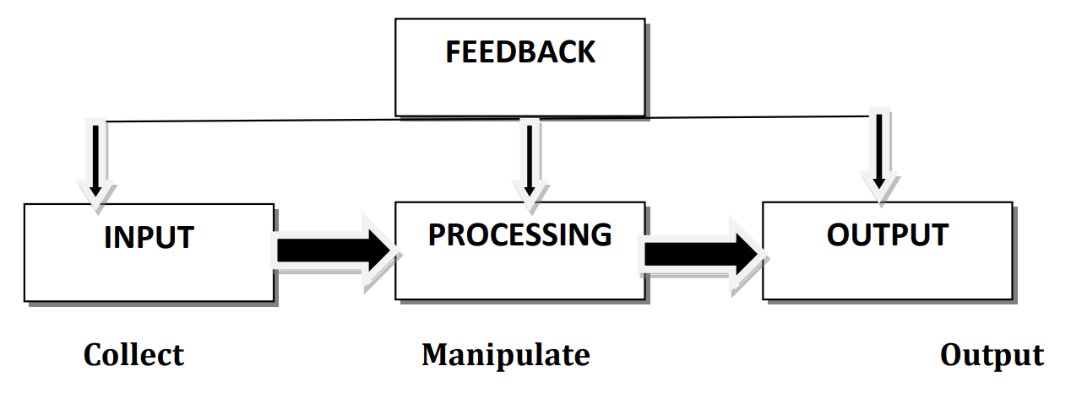

**CBIS (Computer Base Information System)**

* + Hardware
  + Software
  + Database
  + Telecommunication, Network, Internet
  + People (User)
  + Procedure (Includes set of Rules and Regulations)

**UNIT – 2**

**The term system defined as a set of interconnected elements that work together to achieve some common purpose or goal. For example: Human body is a system.**

**Different types System**

* + Simple and Complex
  + Open and Closed System
  + Deterministic and Probabilistic System
  + Stable and Dynamic
  + Permanent and Temporary
  + Adaptive and Non-adaptive
  + Sub-system and super-system

